EXPERIMENT-4

AIM:
Implement histogram equalization on the given image and compare it with the original image using Open CV.
PROGRAM:
import cv2
from tkinter import Tk, filedialog
# Hide Tkinter window
Tk().withdraw()
# Select image
file_path = filedialog.askopenfilename(
title="Select an Image",
filetypes=[("Image Files", "*.jpg *.jpeg *.png *.bmp")]
)
# Check if image selected
if not file_path:
print("No image selected!")
exit()
# Read image
img = cv2.imread(file_path)
if img is None:
print("Error: Unable to load image!")
exit()
# Convert to grayscale
gray = cv2.cvtColor(img, cv2.COLOR_BGR2GRAY)
# Histogram Equalization
equalized = cv2.equalizeHist(gray)
# Display images
cv2.imshow("Original Grayscale Image", gray)
cv2.imshow("Histogram Equalized Image", equalized)
cv2.waitKey(0)
cv2.destroyAllWindows()
INPUT:
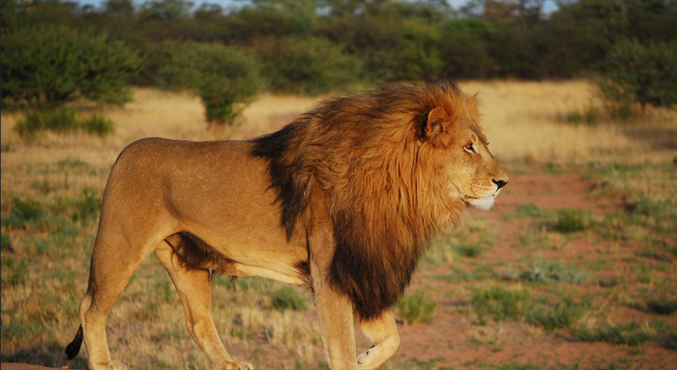
OUTPUT:
